Rectangular Course

WARNING:
All procedures here are GENERALIZED for learning.
Fly the maneuver in accordance with the Pilot Operating Handbook (POH) or
current Standard Operating Procedures (SOPs)

What it is……
- The rectangular course maneuver simulates the airport traffic pattern, demonstrating the effect of wind on an aircraft [Figure 1]

Why we do it…….
The maneuver assists the student pilot in perfecting:
  - Practical application of the turn
  - The division of attention between the flightpath, ground objects, and the handling of the airplane
  - The timing of the start of a turn so that the turn will be fully established at a definite point over the ground
  - The timing of the recovery from a turn so that a definite ground track will be maintained
  - The establishing of a ground track and the determination of the appropriate "crab" angle

How to do it………..

C-172S Procedure:
- Note wind direction and strength, if able
  - Important for finding the downwind and anticipating ground speed
  - Can be determined by trees, water, flags, etc...
- Perform clearing turns
- Pick a reference rectangle in an area where an emergency landing can be made if necessary
  - Fields or perpendicular roads are best
  - Distances should be about 1 mile in length and maintained at the same distance throughout the maneuver
  - The rectangle should be flown outside of the visual references, not on top to enable good visibility of the track
- Establish and maintain 100 KIAS (approx. 2200 RPM) and 1,000' AGL throughout the maneuver maintaining 1/4th to 1/2 mile of lateral distance from the rectangular edges
- Enter the maneuver on a 45° mid-field downwind
  - Ground speed will increase as you enter the pattern
- Turn base at boundary:
  - AOB: Steep AOB, not to exceed 45°, transitioning to medium bank as the turn progresses
  - GS: Decrease, due to lost tailwind
  - Degrees: Turn greater than 90°, to compensate for wind, so as you roll out you have established a crab
- Turn upwind at boundary:
  - AOB: Medium AOB, transitioning shallow as the turn progresses
  - GS: Decrease, you are now flying directly into the wind
  - Degrees: Turn less than 90°, due to the crab already set prior to your turn
- Turn crosswind at boundary:
  - AOB: Shallow AOB, transitioning to medium as the turn progresses
  - GS: Increase, due to the loss of the complete headwind component
  - Degrees: Turn less than 90° to allow for wind correction
- Turn downwind at boundary:
  - AOB: Medium AOB transitioning to a much steeper AOB than earlier, not to exceed 45°
  - GS: Increase, due to the increasing tailwind
  - Degrees: Turn more than 90°
- Depart the maneuver on a 45° mid-field downwind
- Complete cruise checklist

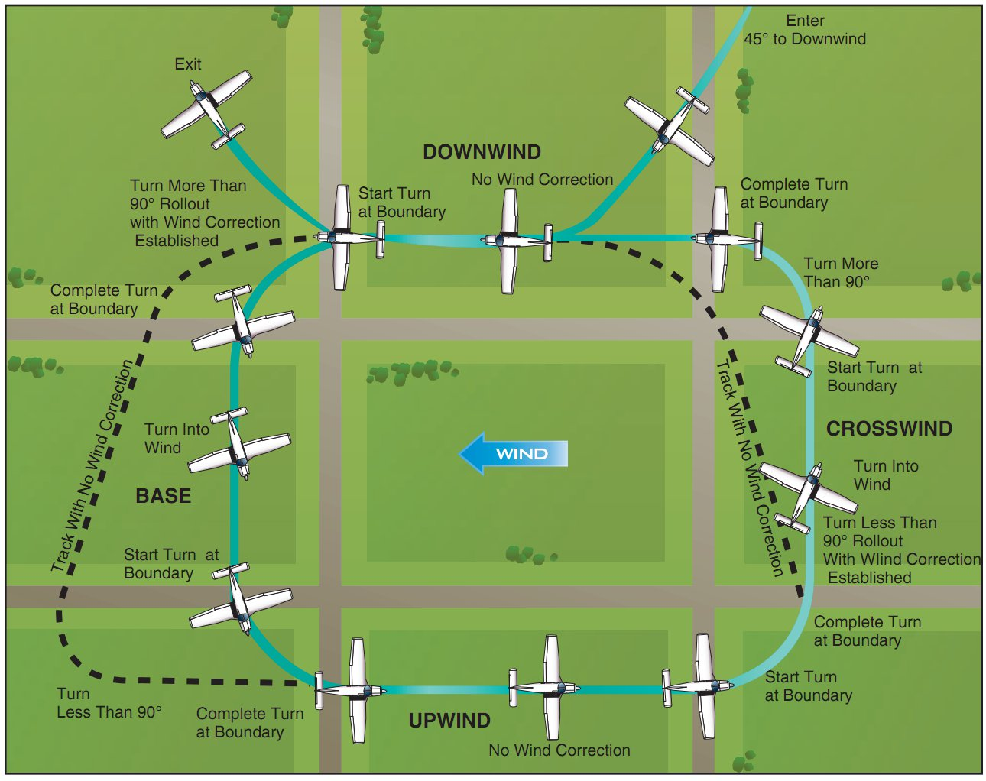
Figure 1: Airplane Flying Handbook, Rectangular Course

Notes:
- It is unusual to find a situation where the wind is blowing exactly parallel to the field boundaries so slight wind corrections on all legs may be required
- It is important to anticipate the turns to correct for groundspeed, drift, angle of bank (AOB), and turning radius
- When the wind is behind the airplane, the turn requires a larger AOB due to the turn radius/rate and vice versa
  - Because of this, you will need to anticipate your turn at different points around the box pattern
  - The higher the ground speed, the earlier you must anticipate the turn
- Altitude and airspeed should be held constant
- Requires utilization of ground track with wind forming a "crab" angle to maintain an equidistant track from all sides of the rectangle
  - Approximately 1/4 to 1/2 mile away
  - For a Cessna, this will be when the edge of the rectangle bisects the wing strut
  - The closer you fly, the steeper the turns will have to be, the farther, the shallower

Common Errors:
- Failure to adequately clear the area
- Failure to establish proper altitude prior to entry (Typically entering the maneuver while descending)
- Failure to establish appropriate wind correction angle, resulting in drift
- Gaining or losing altitude
- Poor coordination (Typically skidding in turns from a downwind heading and slipping in turns from an upwind heading)
- Abrupt control usage
- Inability to adequately divide attention between airplane control and maintaining ground track
- Improper timing to beginning and recovering from turns
- Inadequate visual lookout for other aircraft

Standards:
- Practical Test Standards

Reference:
- Airplane Flying Handbook (6-4) Rectangular Course
- AOPA - Understanding the most basic ground reference maneuver
- CFI Notebook.net - Traffic Pattern
- FAA - Practical Test Standards

